Agenda:

Questions:

* /frontend/src/package.json #42: "react": "17.0.1", -> "react": "~16.11.0",
  + **Tilde Ranges ~1.2.3 ~1.2 ~1**Allows patch-level changes if a minor version is specified on the comparator. Allows minor-level changes if not.
* /frontend/src/package.json #41: "navigation-test-utils": "^0.1.18", -> [removed]
  + https://github.com/crowdlinker/navigation-test-utils
  + no apparent references to this library project outside of documentation unless Julio knows more about its usage
* npm i --legacy-peer-deps from /frontend/src/ instead of /frontend/
  + deviation from setup instructions
* database connection:
  + /storage/config/ npm start fails due to refused connection
  + 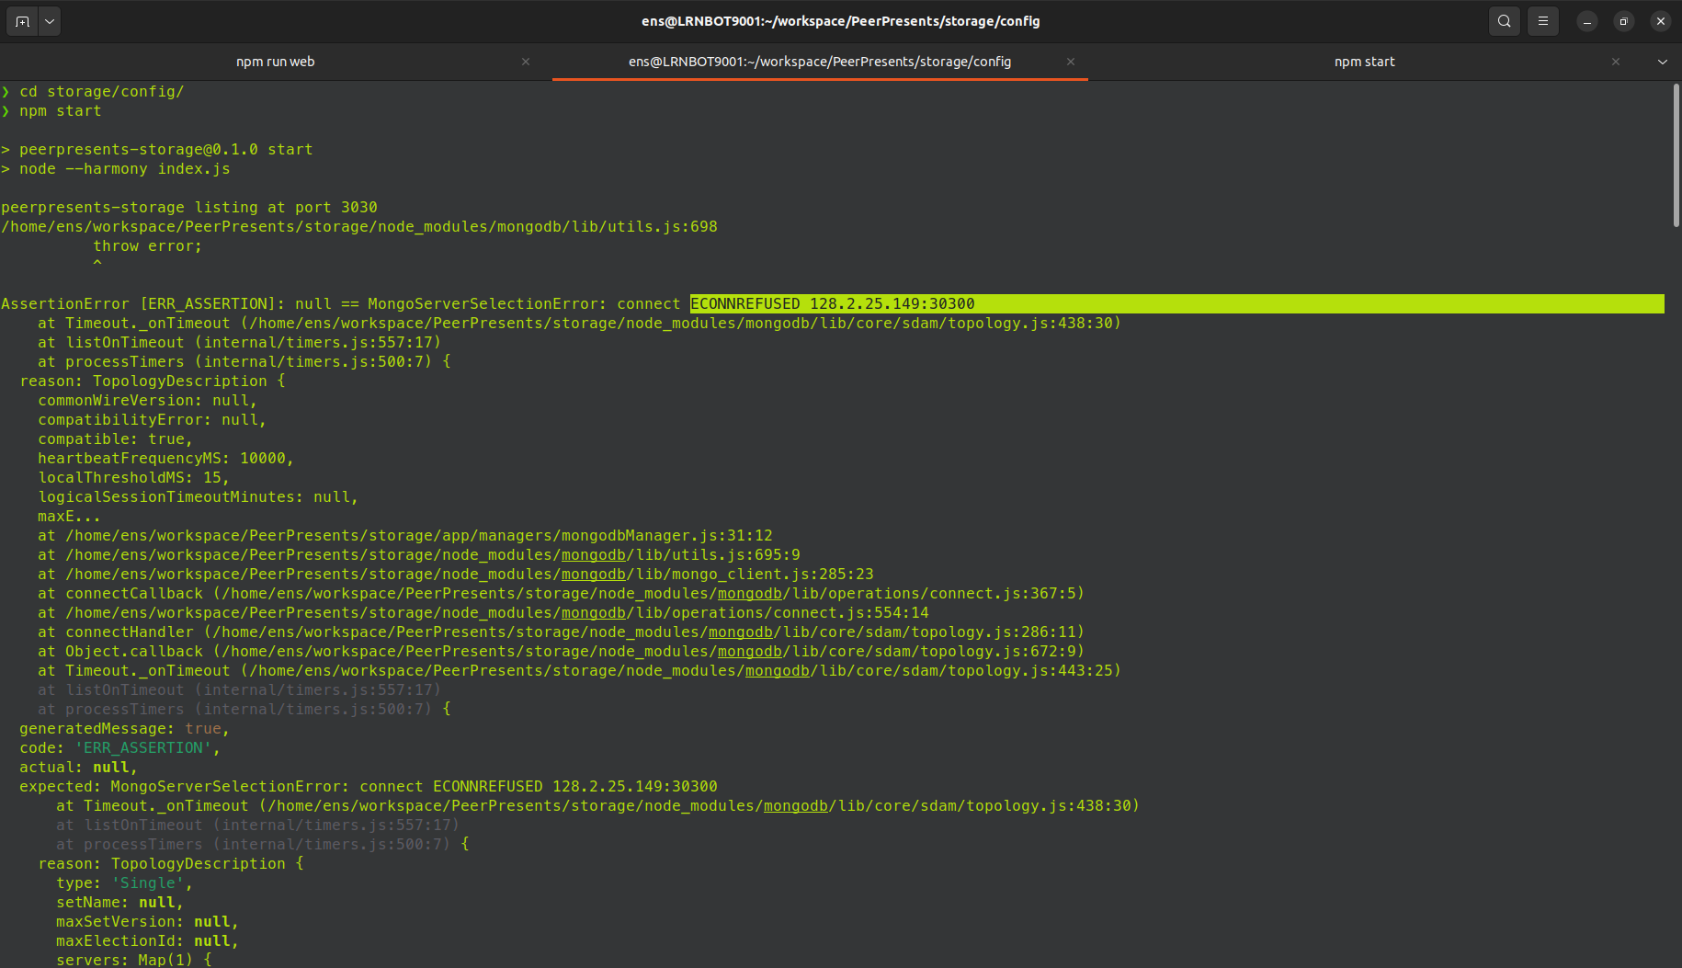
  + 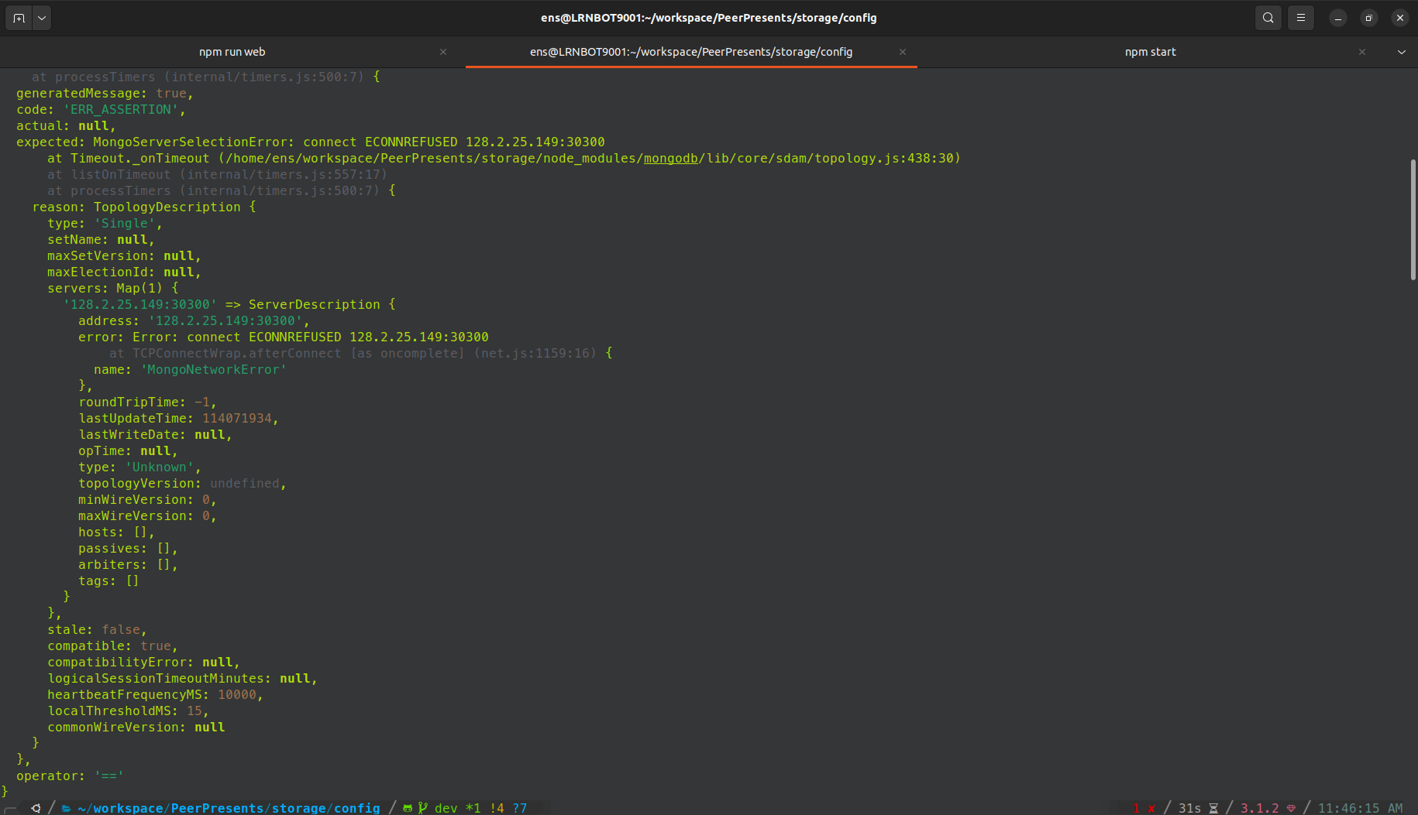
* **Database is refusing connection** - appears to be trying to connect to the live database
* ECONNREFUSED 128.2.25.149:30300 which corresponds with ppdb_conf active ip & port; should we instead be using lines 3 and/or 5 (127.0.0.1:27017) or some other configuration?
* Note: peerpresents-storage listing at port 3030 but trying to connect to port 30300 - is this correct?
* Also /backend_worker/config/ fails on npm start with:
  + Missing script: "start"
  + Should we just add this line to the package.json?

Meeting:

* Mostly troubleshooting in real-time with Julio
* Approved changes such as removing obsolete dependencies (i.e. navigation-test-utils) when they're not used elsewhere in the project
* Approved upgrading/downgrading module versions as needed to unbreak process
* DB setup: repo has a guide under the README.md file at Administration -> Server setup guide - configure mongo DB for local development guide contained to set up local db for development
* needed to run local dev:
  + backend_master, storage, and source file, and then it, "should work just fine"
  + backend_worker isn't necessary
* recommend cd into every single place and running npm install
  + manual install is an alternative when we can identify which modules are failing for npm start/install
  + yarn add command to download automatically if you
* Julio will generate updated ppdb_conf and api_conf files and send to us
* Met 4:05-4:50pm 2/14/23

Action Items:

* Primary goal is still dev environment setup
* Share changes made to any of the package.json files
* Continue troubleshooting /backend_master/config npm start
  + Error: Cannot find module './helpers/error -> track down source
    - potentially relevant file location: PeerPresents/backend_master/app/app.js line #6
* Julio is available through Discord once we've made some progress or have questions that arise